CSE 581

**Lab 10: Data Manipulation**

1.1

INSERT INTO Users(NTID, FirstName, MiddleInitial, LastName, EmailAddress,Password)

VALUES ('01-HJPotter', 'Harry', 'J','Potter', 'hp@hw.edu', 'Hedwig'),

('02-RBWeasley', 'Ron', 'B','Weasley', 'rw@hw.edu', 'Scabbers'),

('03-HJGranger', 'Hermione','H','Granger', 'hg@hw.edu', 'Crookshanks'),

('10-Rlupin', 'Remus', NULL,'Lupin', 'rl@hw.edu', 'moon'),

('11-Fflitwick', 'Filius', NULL,'Flitwick', 'ff@hw.edu', NULL),

('16-Rhagrid', 'Rubeus', NULL,'Hagrid', 'RH@hw.edu', 'BuckBeak');

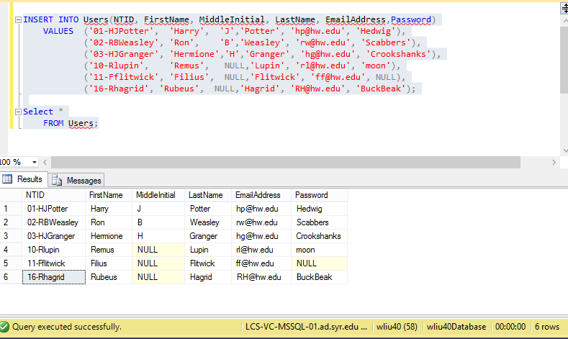

1.2

INSERT INTO Courses(CourseId, CourseCode, CourseTitle, Faculty, OpenSeats)

VALUES (1, 'DADA101', 'Defence Against the Dark Arts BASIC','10-Rlupin', 3),

(2, 'DADA201', 'Defence Against the Dark Arts INTERMEDIATE','10-Rlupin', 2),

(3, 'DADA301', 'Defence Against the Dark Arts ADVANCED','10-Rlupin', 1),

(4, 'CHMS101', 'Charms BASIC','11-Fflitwick', 2),

(5, 'CHMS201', 'Charms INTERMEDIATE','11-Fflitwick', 0),

(6, 'CHMS301', 'Charms ADVANCED','11-Fflitwick', 4),

(7, 'HOM101', 'History of Magic BASIC',NULL, 10);

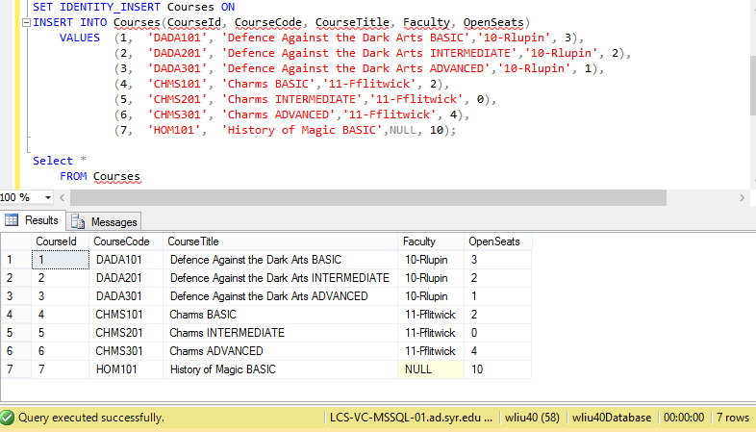

1.3

SET IDENTITY_INSERT LetterGrades ON

INSERT INTO LetterGrades(LetterGradeId, LetterGrade, Description)

VALUES (1, 'O', 'Outstanding'),

(2, 'E', 'Exceeds Expectations'),

(3, 'A', 'Acceptable'),

(4, 'P', 'Poor'),

(5, 'D', 'Dreadful'),

(6, 'T', 'Troll');

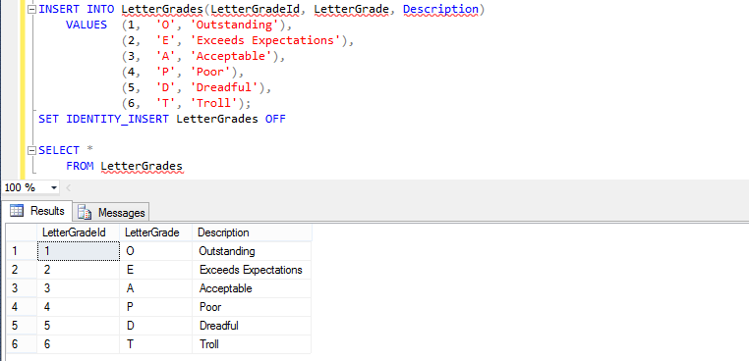

1.4

INSERT INTO CourseGrade(GradingScaleId, LetterGradeId, CourseId, GradeValue)

VALUES (1, 1, 1, 95),

(2, 2, 1, 90),

(3, 3, 1, 80),

(4, 4, 1, 70),

(5, 5, 1, 60),

(6, 6, 1, 0),

(7, 1, 2, 100),

(8, 2, 2, 90),

(9, 3, 2, 85),

(10, 4, 2, 75),

(11, 5, 2, 64),

(12, 6, 2, 0);

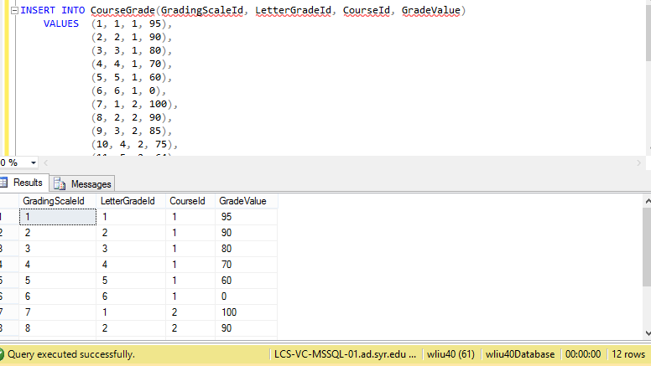

1.5

INSERT INTO CourseEnrollment (EnrollmentId, StudentId, CourseId, FinalGrade)

VALUES (1, '01-HJPotter', 1, NULL),

(2, '01-HJPotter', 4, NULL),

(3, '03-HJGranger', 1, NULL),

(4, '03-HJGranger', 4, NULL),

(5, '02-RBWeasley', 1, NULL),

(6, '02-RBWeasley', 4, NULL);

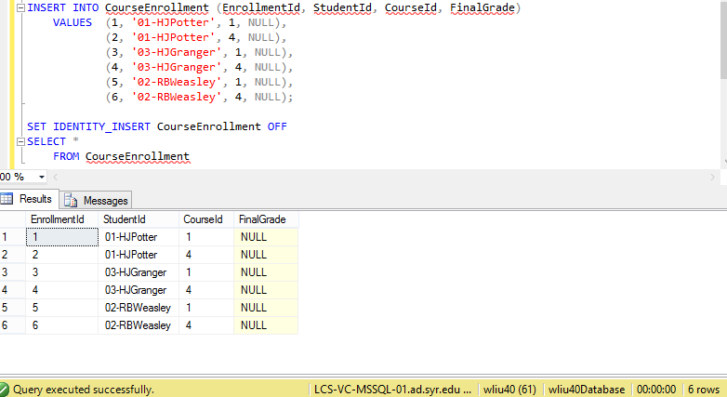

2(a)

UPDATE Courses

SET Faculty = '16-Rhagrid'

WHERE Faculty = '10-Rlupin';

DELETE FROM Users

WHERE NTID = '10-Rlupin';

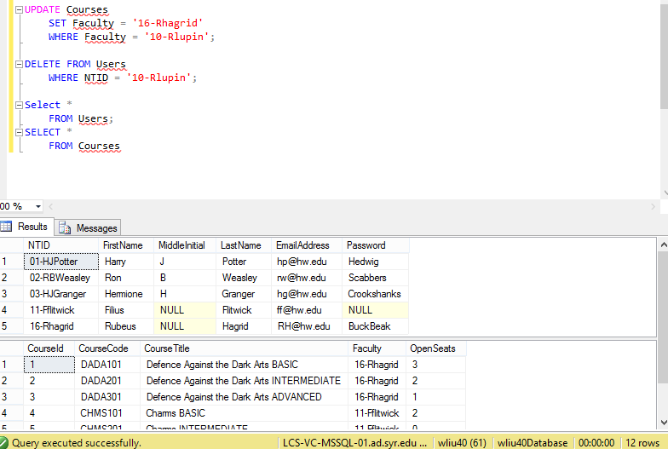

2(b)

UPDATE CourseEnrollment

SET FinalGrade = 96

WHERE StudentId = '01-HJPotter'

AND CourseId = 1

UPDATE CourseEnrollment

SET FinalGrade = 91

WHERE StudentId = '01-HJPotter'

AND CourseId = 4

2(c)

UPDATE CourseEnrollment

SET FinalGrade = 91

WHERE StudentId = '02-RBWeasley'

AND CourseId = 1

UPDATE CourseEnrollment

SET FinalGrade = 88

WHERE StudentId = '02-RBWeasley'

AND CourseId = 4

2(d)

UPDATE CourseEnrollment

SET FinalGrade = 92.22

WHERE StudentId = '03-HJGranger'

AND CourseId = 1

UPDATE CourseEnrollment

SET FinalGrade = 99

WHERE StudentId = '03-HJGranger'

AND CourseId = 4

2(e) & (f)

INSERT INTO CourseEnrollment (EnrollmentId, StudentId, CourseId, FinalGrade)

VALUES (7, '01-HJPotter', 2, NULL),

(8, '03-HJGranger', 6, NULL);

